**The Cliffords, the Cumberlands and the Devonshires:**

**their history and connections with Craven and Rylstone**

**The Clifford family from Norman to Tudor times[1]** **[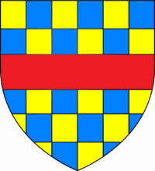](https://en.wikipedia.org/wiki/File:CliffordArms.png)**

The Clifford family were Norman barons, descended from Richard I of Normandy. Their main family seat in England was at Clifford Castle, Herefordshire, from where they took their English name. They first came to Craven in 1310 when Robert de Clifford was granted Skipton Castle and its surrounding lands to the North and West of Skipton by Edward II who also appointed him the **1st** **Lord Clifford and Guardian of Craven**. According to Skipton Castle records, he began fortifying his new castle but did not live long enough to complete the task fully since he was killed in 1314 at the Battle of Bannockburn.

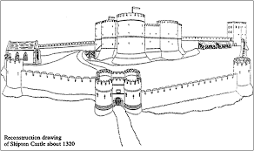

Skipton Castle about 1320. From Skipton Castle website

The castle and lands passed to his young son **Roger de Clifford, 2nd Lord Clifford**, who was badly injured at an uprising of Northern barons against Edward II. Roger was attainted, but spared by the king because of his injuries and subsequently died childless in 1327. The barony then passed to his brother, **Robert de Clifford, 3rd Lord of Skipton** who died in 1344. The Clifford lands in Skipton and elsewhere (including those in Westmorland in and around their Appelby, Brough, Brougham and Pendragon Castles) were nearly forfeited by the crown because of Roger's involvement in the insurgency. Indeed, it appears that subsequent generations often spent as much time on their Westmorland estates as they did at Skipton.

After the third Lord, there existed a series of Lords Cliffords (Robert, the fourth lord; Roger, the fifth; Thomas, the sixth; John, the seventh; Thomas, the eighth) whose relationships with the reigning monarchs, according to Whitaker (1878), were highly variable. There were instances of the Clifford family nearly losing their lands because of further uprisings against the crown, and indeed the eighth Lord Clifford was killed at the Battle of St Albans in 1455, fighting for the Lancastrians against the monarchy. Others, however, were strong supporters of the monarch and received due credit for this in terms of further estates and titles.

The **9th Lord, John Clifford** (born in 1435), lived mostly on his Westmorland estates, visiting Skipton only occasionally and with the Skipton lands, according to Whitaker, *'mostly in lease'*. He was quite pugnacious and pursued the House of York, in revenge for his father's death *'with a rancour which rendered him odious',* according to Whitaker, *'even in that ferocious age*'. He was killed at the Battle of

Towton, near Ferrybridge in Yorkshire, was attainted and the Clifford lands

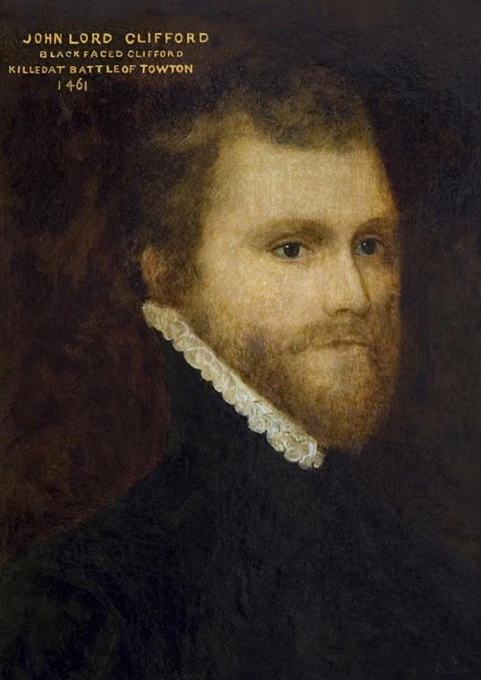

John 9th Baron Clifford. Skipton Castle website

temporarily confiscated by the Crown. They were restored to the Clifford family by Henry VII in the first year of his reign (1485/86). Previously John had married Margaret Bromflet, daughter of Lord Vescy.

**Henry, the 10th Lord Clifford** inherited the Vescy barony from his mother and became both Lord Clifford and Lord Vescy, although the Vescy name seems to have received lower precedence than that of 'Clifford'. By all accounts, he was ill-educated but intelligent, rather eccentric and lived mostly a quiet life without ceremony. Whilst born at Skipton Castle, he was removed as a boy to Westmorland for safety after his father had killed Edmund, the Kings brother and then also been killed himself. Henry became known as the 'Shepherd Lord' because of his pastoral pursuits as a child, but after inheriting the Clifford barony, he came back to Skipton and often based himself at Barden Tower. He distinguished himself late in life at the Battle of Flodden before dying aged about 70 in 1524. He is said to be buried at Bolton Priory.

His son, also **Henry Clifford, the 11th Lord** (born 1493), was active in court circles and created **Earl of Cumberland** in 1525 by Henry VIII, probably because of his support for the king in his battles with the Scots. He married Margaret, daughter of the Earl of Shrewsbury, and then upon her death, Lady Margaret Percy, sister to the Lord of Northumberland, acquiring the whole of the Percy 'fee' upon his brother in law's death. Shortly before he died in 1542 (at the age of only 49) he was also granted Bolton Priory and its lands, together with various local Craven manors, as a reward for his loyalty to the crown.

He was succeeded by yet another **Henry, the 12th Lord Clifford and 2nd Earl of Cumberland**, who, according to Whitaker (1878), *'falling upon tranquil times, enjoyed his honours without disturbance, but without renown'*. He did, however, support the crown against the uprising by the Lords of Northumberland and Westmorland. He had warm relations with the royal family, not least because of his marriage to Lady Ellenor Brandon, daughter of the Duke of Suffolk and Mary, Queen Dowager of France, daughter of Henry VII. Upon her death, he married Anne, daughter of Lord Dacre. He died at Brougham Castle on his Westmorland estate in 1569, but was buried at Skipton.

The portrait of **George Clifford, 13th Lord Clifford** suggests that the **3rd Earl of Cumberland** was an imposing figure, with a military bearing. He was a favourite of

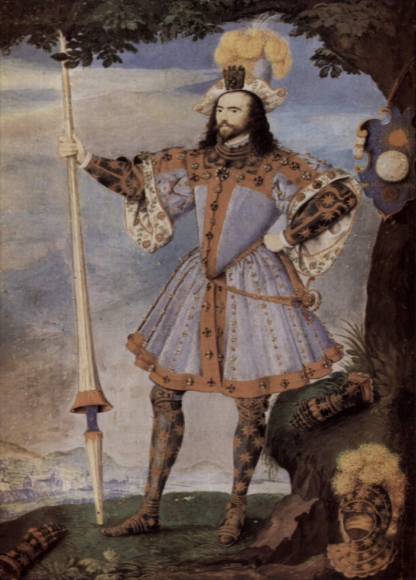

George Clifford, 13th Lord Clifford

Portrait as Queen's Champion. National Portrait Gallery.

Queen Elizabeth and was frequently at court. He was made the Queen's Champion and then a Knight of the Garter in 1592. The queen may have been impressed, not only with his courtly appearance, but by his seafaring expeditions. He was said to have made nine of these, mostly to the West Indies. He died in London in 1605, aged 47. Whitaker is scathing about George the man in the following terms:

*'If we trace him in the public history of his times, we see nothing but the accomplished courtier, the skilful navigator, the intrepid commander, the disinterested patriot. If we follow him into his family, we are instantly struck with the indifferent and unfaithful husband, the negligent and thoughtless parent.'.......'He set out with a larger estate than any of his ancestors, and in no more than twenty years he made it one of the least'.*

George married Margaret, daughter of the Earl of Bedford in 1577 in the presence of Queen Elizabeth. They had three children - two boys who died young - and a girl, Ann. Because of George's serial infidelity, this was an unhappy marriage and they lived separately for much of the time, with Margaret spending her time latterly in Westmorland.

When George died, his brother, Francis, who was born in Skipton Castle in 1559, became the **4th Earl of Cumberland**, but not Baron de Clifford, owing to a quirk in his father's will. He lived at Skipton Castle all his long life and died there aged 80, with his son **Henry, the 5th and last Earl**, managing his estates in his latter years.

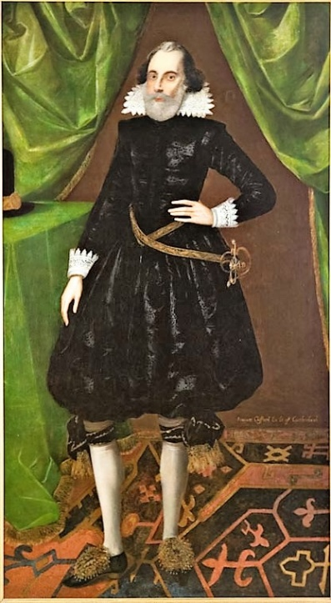 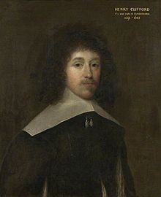

Francis Clifford, 4th Earl of Cumberland[2] Henry Clifford, 5th Earl of Cumberland[3]

The daughter of George and Margaret, **Lady Ann Clifford**, was born at Skipton Castle in 1590 and inherited the de Clifford barony from her father in 1605. Although the Skipton estate was intended by George to be left with the earldom, it eventually went in full (after a long battle with Francis and Henry) with the barony to Ann after Henry's death. Here is the wikipedia explanation for this complex inheritance:

*'On the death of her father on 30 October 1605, she succeeded* [*suo jure*](https://en.wikipedia.org/wiki/Suo_jure) *to the ancient title* [*Baroness de Clifford*](https://en.wikipedia.org/wiki/Baron_de_Clifford)*, a barony created by*[*writ*](https://en.wikipedia.org/wiki/Writ)*in 1299, but her father's earldom passed (according to the*[*patent*](https://en.wikipedia.org/wiki/Letters_patent)*of its creation) as was usual, to the*[*heir male*](https://en.wikipedia.org/wiki/Heir_male)*, namely his younger brother*[*Francis Clifford, 4th Earl of Cumberland*](https://en.wikipedia.org/wiki/Francis_Clifford,_4th_Earl_of_Cumberland)*(1559-1641), to whom he had willed his estates. He had bequeathed to Anne the sum of £15,000. In her young adulthood she engaged in a long and complex legal battle to obtain the family estates,*[*[6]*](https://en.wikipedia.org/wiki/Lady_Anne_Clifford,_14th_Baroness_de_Clifford#cite_note-6)*which had been granted by King*[*Edward II*](https://en.wikipedia.org/wiki/Edward_II)*(1307-1327) under*[*absolute cognatic primogeniture*](https://en.wikipedia.org/wiki/Primogeniture#Absolute_cognatic_primogeniture)*, instead of the £15,000 willed to her. Her main argument was that she was just 15 years old at the time. It was not until the death in 1643 without male progeny of*[*Henry Clifford, 5th Earl of Cumberland*](https://en.wikipedia.org/wiki/Henry_Clifford,_5th_Earl_of_Cumberland)*, the 4th Earl's only son, that Anne managed to regain the family estates, although she did not obtain possession until 1649'.*

Lady Ann Clifford was to become famous because of her intelligence, her literary activities, her beneficence and her pursuance of her rights to the Clifford estates after her father's death. She undertook a great deal of restoration work on her castles and moved her residence between them. She was felt to be way ahead of her time and leaves a well documented legacy of her life and actions.

Ann married Richard Sackville, 3rd Earl of Dorset in 1609, with whom she had five children, but only two girls survived to adulthood. She was widowed in 1624 and then married [Philip Herbert, 4th Earl of Pembroke and 1st Earl of Montgomery](https://en.wikipedia.org/wiki/Philip_Herbert,_4th_Earl_of_Pembroke) in 1630. He died in 1650 and Ann died in 1676 at Brougham Castle.

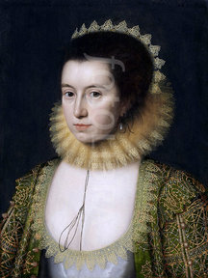 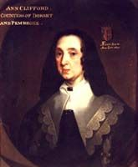

Lady Ann Clifford in her youth[4] Lady Ann Clifford in mature age[5]

**Cliffords and Nortons - two families in opposition**

In Tudor times, the Cliffords' Skipton lands adjoined the Rylstone estate of the Nortons with the dividing line being Waterford Gill, a deep gulley sited below Scale House. The Nortons were a family of lower nobility status than the Cliffords, but who nevertheless owned various estates in North and East Yorkshire, including Rylstone manor. They acquired the Rylstone estate through John Norton's marriage to Ann Radcliffe, grand-daughter of William de Rilston at the time of their marriage in 1492/3. Their main residence was, however, at Norton-Conyers near Wrath, from where they took their full name of 'Norton-Conyers'. Like the Cliffords, they were descended from Norman knights - the Norvilles and Coniers.

It is evident that before Tudor times, the Nortons and Cliffords moved in very similar circles in the North of England. Both had strong connections, and inter-married, with the Neville and Percy families; otherwise the houses of the Earls of Westmorland and Northumberland, as well as with other Northern gentry. Indeed, there is at least one instance of a direct inter-marriage when Anne Clifford, daughter of Thomas, 8th Baron de Clifford married her second husband William Norton-Conyers?

When Henry VIII established the Church of England and split from the Roman church, the Cliffords supported the reforms made by both Henry and Queen Elizabeth, and were often seen at court. The Nortons, along with the Percys and Nevilles, meanwhile, were strong adherents of the old catholic faith and became enemies of the Cliffords.

They also came to blows over hunting rights on Rylstone Fell with John Norton of Rylstone manor in dispute with Lord Clifford, 1st Earl of Cumberland, in the early decades of the 16th century over these rights.

The dispute hinged on whether or not Norton's manor at Rylstone was within Cumberland's forest of Skipton, as the following abstracts from a North Craven Heritage Trust document (undated) describe:

*'Norton claimed that its attached right of free warren entitled him to keep his own deer park there; whereas Cumberland counter-claimed that, because the manor was part of his forest, Norton had no such right and therefore all the deer belonged to the Cliffords. Norton's claim caused him to construct a palisaded park in Rylstone for the deer; Cumberland's claim caused him to seek its removal'*.

The issue affected the whole community of Rylstone and came to a head in 1535 since, as the NCHT document recounts:

*'...in attacking Norton's deer park, Cumberland's men had threatened his servants and tenants for maintaining it. Moreover, as well as seeking to remove an enclosure in Rylstone, Cumberland was intent on enclosing moorland to which the people of Rylstone had commoning rights, in order to create additional farms. This offended them by reducing the extent of the waste to which their rights appertained while increasing the demands that were made of its natural resources.*

*Central to the dispute and affecting the whole community was the issue of whether the people of Rylstone could properly regard the free-ranging deer within the manor's bounds as there by right or as intruders which could be lawfully driven out, impounded or slaughtered. It was very much in their interest to support Norton's park since it trapped the deer wandering in from the adjacent forests and prevented them from damaging crops and underwood. The problem of free-range deer was a serious one, simply because of the extent of the adjoining chases which reached eastwards into Nidderdale, as well as northwards into Langstrothdale, and which contained, principally for the benefit of Cumberland and his affinity, huge numbers of deer. Compounding the problem created by an excess of free-range but reserved deer was Cumberland's aggressiveness in preserving his exclusive rights. The feud over Rylstone between Cumberland and Norton led to the imprisonment of one of Norton's servants in Skipton Castle and the expulsion of another from the manor. Moreover, the threats made by Clifford hunting parties, and the damage they inflicted, left Norton's tenants, or so they said, with little incentive to carry out the essential requisite of successful farming in the region: the manuring or slurrying of the pasture land. The problem was not confined to the community of Rylstone. As defined by the Cliffords, the forest of Skipton included Eshton, Flasby, Hetton (that is, much of the lordship of Winterburn), Cracoe, Thorpe and Burnsall. For this very reason, the parishes called upon to meet at Rylstone on 12th December [1535] included a large number of communities which were bothered by Cumberland's deer'.*

The dispute also led to a court case, the outcome of which was won by John Norton, who retained his right to herd deer and enclose a deer park.

The mutual antagonism, however, did not stop there. John Norton and his eldest son, Richard, who was even more of a fervent catholic than his father, took part in the 1536 Pilgrimage of Grace[6]. The Pilgrimage of Gracewas a popular uprising in Yorkshire in the autumn of 1536 by the Northern catholic gentry against Henry VIII's break with the Roman Catholic Church, the Dissolution of the Monasteries and the policies of the King's chief minister, Thomas Cromwell.

As part of this, the Nortons and other insurgents besieged Henry, 1st Earl of Cumberland in Skipton Castle. The story is retold as follows by the NCHT:

*'Between Friday 13th and Wednesday 18th October* [1536] *a number of important knights and gentry were sworn to the commons and were responsible for organising an ill-disciplined and unruly rabble into an effective force. On the Wednesday the army was divided into two companies one to march to Pontefract and the other to Skipton. The purpose of going to Skipton was to capture Lord Scrope* [King's supporter and lord of Bolton Castle] *who had fled to his father-in-law's castle at Skipton. The company marched through Pately Bridge to Skipton sweeping-up Sir Ninian Markenfield of Markenfield; William Mallory of Studley and John Norton of Norton Conyers en route'.*

*'... after the 18th, the Richmondshire force arrived at Skipton Castle where the earl had gathered five hundred of his men but, on hearing of the coming of the rebels, the entire Clifford force defected and returned to defend their own properties.*

*'Christopher Aske, the brother of Richard[7], was the earl’s receiver and had fled from the East Riding when it rose, travelling to Skipton for safety. Christopher Aske was loyal to the earl and organised the defence of the castle with eighty household servants and forty randomly recruited young men. The earl raised his standard above the castle and sent word to the commons that he would not be taken alive'.*

*'Eventually the gathering dispersed* [after 2-3 days] *having achieved nothing and went on their way to Pontefract. But the Earl had been immobilised throughout the rising. Much of his property elsewhere had been vandalised, plundered by his own tenants and his authority had collapsed.'*

It was about this time, or in the next decade, that the Nortons (commonly cited as Richard Norton) built Norton Towers on a bluff near the South Eastern edge of their property overlooking Waterford Gill and the main route-way through the valley from Grassington via Rylstone to Skipton. It is significant that the Tower overlooked the boundary with the Clifford lands, and one view is that the Tower was a watch tower to keep an eye on the Cliffords and their marauding deer-hunting trips. Another view is that it was simply a hunting lodge for summer outdoor pleasures. Perhaps it could have fulfilled both functions.

It is, however, noteworthy that the Cliffords were also said to have built a watch tower on the other side of Waterford Gill - almost certainly to spy on the Nortons, but maybe also doubling as a hunting box, according to Whitaker. The Tower was said (by the Rev. Carr, referred to by Whitaker), as being called Newhall or Clifford's Tower and consisted of two rooms and of about five yards square.

Richard Norton was pardoned for his involvement in the Pilgrimage of Grace and as we see in Stoney and Thake (2016) Richard went on to have high office in the North during the reign of Queen Elizabeth. There were continued antagonisms and feuding, however, between the Nortons and Cliffords, who had designs on the Nortons' Rylstone estate as well as on their deer.

Richard's star and that of the Norton family fell dramatically in 1569, when Richard and some of his many sons became involved in the Uprising of the North - an attempt to replace Elizabeth with Mary Queen of Scots on the throne and so restore the old catholic faith to England (see e.g. Sharp, 1840). Indeed, Richard was one of the ringleaders and by then quite elderly and known as 'Old Norton' (again see Stoney and Thake, 2016). After the Uprising failed, the crown took away the Norton manors and lands from the family and the Rylstone manor was given to the Cliffords in 1605. The Cliffords, having wished to have this property for so long, promptly sold off the lands and tenancies and the Rylstone manor house fell into dilapidation over coming centuries and no lord of the manor lived there again.

As we have seen above, the Cliffords continued to own Skipton Castle and its manorial lands until after Lady Ann Clifford died and the inheritance passed to the Tuftons - the Earls of Thanet through the marriage of her daughter. Today the castle is owned by the Fattorini family and has been owned by them for many decades.

**The Cliffords and Cumberlands become the Cavendishs and Devonshires**

Just to confuse matters, there are several different lines of Clifford barons, of which two are of interest to us: the Barons de Clifford (of 1310 creation) and the Baron Cliffords (of 1628 creation).

The **Baron de Clifford** appellation passed down the main Clifford and Cumberland line from Lord George Clifford, third earl of Cumberland, to his daughter Lady Ann Clifford and her heirs. It is still extant, with the list of Barons de Clifford - male and female - given as an appendix to this report.

According to Wikipedia,the title, **Baron Clifford,** was created by virtue of Lord [Henry Clifford](https://en.wikipedia.org/wiki/Henry_Clifford,_5th_Earl_of_Cumberland), fifth earl of Cumberland's summons to attend Parliament and represent Skipton in 1628. Upon his death in 1643, his daughter [Elizabeth](https://en.wikipedia.org/wiki/Richard_Boyle,_1st_Earl_of_Burlington) succeeded to the title (although she never made claim to it). Lady Elizabeth Clifford had married, in 1634, [Richard Boyle, 1st Earl of Burlington and 2nd Earl of Cork](https://en.wikipedia.org/wiki/Richard_Boyle,_1st_Earl_of_Burlington). The Clifford barony was held by the [Earls of Burlington and Cork](https://en.wikipedia.org/wiki/Earldom_of_Burlington) until the death of the [3rd and last Earl of Burlington](https://en.wikipedia.org/wiki/Richard_Boyle,_3rd_Earl_of_Burlington) in 1753[8]. It then devolved upon [[Lady Charlotte Elizabeth Boyle](https://en.wikipedia.org/wiki/Charlotte_Cavendish,_Marchioness_of_Hartington), [6th Baroness Clifford](https://en.wikipedia.org/wiki/Baron_Clifford) (1731–1754), the daughter and heiress of [Richard Boyle, 3rd Earl of Burlington](https://en.wikipedia.org/wiki/Richard_Boyle,_3rd_Earl_of_Burlington).](https://en.wikipedia.org/wiki/Charlotte_Cavendish,_Marchioness_of_Hartington)

On 28 March 1748, Charlotte married [William Cavendish](https://en.wikipedia.org/wiki/William_Cavendish,_4th_Duke_of_Devonshire), then the [Marquis of Hartington](https://en.wikipedia.org/wiki/Marquess_of_Hartington), who later became the 4th [Duke of Devonshire](https://en.wikipedia.org/wiki/Duke_of_Devonshire) and the [Prime Minister of Great Britain](https://en.wikipedia.org/wiki/Prime_Minister_of_the_United_Kingdom). They had four children [William](https://en.wikipedia.org/wiki/William_Cavendish,_5th_Duke_of_Devonshire), [Dorothy](https://en.wikipedia.org/wiki/Dorothy_Bentinck,_Duchess_of_Portland), [Richard](https://en.wikipedia.org/wiki/Lord_Richard_Cavendish_(1752%E2%80%931781)), and [George](https://en.wikipedia.org/wiki/George_Cavendish,_1st_Earl_of_Burlington). This advantageous union had been arranged since childhood and was happy. The marriage helped William Cavendish rise politically. Through Charlotte, the Devonshires inherited [Chiswick House](https://en.wikipedia.org/wiki/Chiswick_House) and [Burlington House](https://en.wikipedia.org/wiki/Burlington_House) in London; [Bolton Abbey](https://en.wikipedia.org/wiki/Bolton_Abbey) and [Londesborough Hall](https://en.wikipedia.org/wiki/Londesborough_Hall) in Yorkshire; and [Lismore Castle](https://en.wikipedia.org/wiki/Lismore_Castle) in [County Waterford](https://en.wikipedia.org/wiki/County_Waterford), [Ireland](https://en.wikipedia.org/wiki/Ireland).

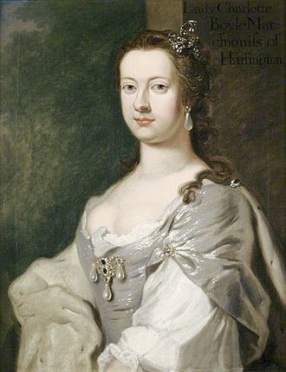 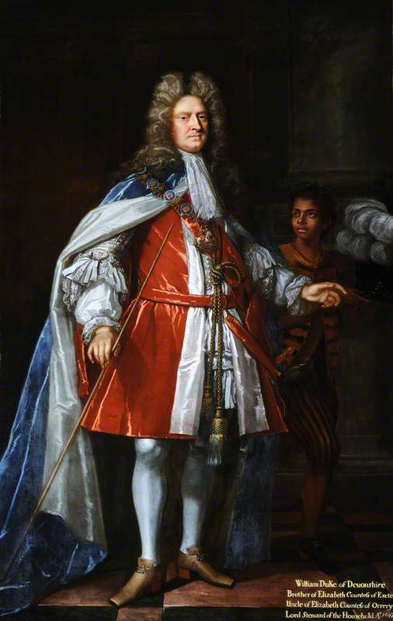

Charlotte, Baroness Clifford and Duchess of Devonshire and the First Duke of Devonshire

The barony of Clifford was held by the [Dukes of Devonshire](https://en.wikipedia.org/wiki/Dukes_of_Devonshire) until the death of [William Cavendish, 6th Duke of Devonshire](https://en.wikipedia.org/wiki/William_Cavendish,_6th_Duke_of_Devonshire) in 1858, when it fell into [abeyance](https://en.wikipedia.org/wiki/Abeyance) as it still remains. The Barons Clifford are also listed in the appendix.

The main seat of the Dukes of Devonshire is, of course, at Chatsworth House in Derbyshire, although they are very active at Bolton Abbey and the present Duke and his wife lived there before inheriting the dukedom. Through their Bolton Abbey estate, the Devonshire family owns Rylstone fell and a considerable amount of land in Rylstone parish, including Manor Farm.

**References**

# Collins, A. (1741). *The English Baronetage: Containing a Genealogical and Historical Account of All Barons Existing...,* Volume 1. London: Thomas Wotton. Available at: <http://www.forgottenbooks.com/readbook_text/The_Baronetage_of_England_Containing_a_Genealogical_and_Historical_1000894518/179.>

Hoyle, R. W. (1986). The First Earl of Cumberland: A Reputation Reassessed. *Northern History.* Vol. XXII.

www.northcravenheritage.org.uk/NCHT/RoyPriceArchive/.../Backupofthe1535riots in craven.

www.northcravenheritage.org.uk/NCHT/.../ThePilgrimageofGraceinCraven.doc.

Sharp, C. (1840). *Memorials of the Rebellion of 1569*. Original Publisher: London: John Bowyer Nicholas and son. Available at: <https://books.google.co.uk/books?id=zWcPAAAAYAAJ>

Skipton Castle Website. [http://www.skiptoncastle.co.uk/hist.](http://www.skiptoncastle.co.uk/hist.%20)

Stoney, S. M. and Thake, A. (2016).*The Norton Family*. Rylstone Investigative Project website.

Whitaker, T.D. (3rd Edition, 1878, republished 1973). *The Deanery of Craven*. Volume 2, pp. 517-528. Menston: The Scolar Press Ltd.

**Barons de Clifford**

* [Robert de Clifford, 1st Baron de Clifford](https://en.wikipedia.org/wiki/Robert_de_Clifford,_1st_Baron_de_Clifford) (1274–1314)
* [Roger de Clifford, 2nd Baron de Clifford](https://en.wikipedia.org/wiki/Roger_de_Clifford,_2nd_Baron_de_Clifford) (1299–1322)
* [Robert de Clifford, 3rd Baron de Clifford](https://en.wikipedia.org/wiki/Robert_de_Clifford,_3rd_Baron_de_Clifford) (1305–1344)
* [Robert de Clifford, 4th Baron de Clifford](https://en.wikipedia.org/w/index.php?title=Robert_de_Clifford,_4th_Baron_de_Clifford&action=edit&redlink=1) (1329–1350)
* [Roger de Clifford, 5th Baron de Clifford](https://en.wikipedia.org/wiki/Roger_de_Clifford,_5th_Baron_de_Clifford) (1333–1389)
* [Thomas de Clifford, 6th Baron de Clifford](https://en.wikipedia.org/wiki/Thomas_de_Clifford,_6th_Baron_de_Clifford) (1363–1391)
* [John Clifford, 7th Baron de Clifford](https://en.wikipedia.org/wiki/John_Clifford,_7th_Baron_de_Clifford) (1388–1422)
* [Thomas Clifford, 8th Baron de Clifford](https://en.wikipedia.org/wiki/Thomas_Clifford,_8th_Baron_de_Clifford) (1414–1455)
* [John Clifford, 9th Baron de Clifford](https://en.wikipedia.org/wiki/John_Clifford,_9th_Baron_de_Clifford) (1435–1461)
* [Henry Clifford, 10th Baron de Clifford](https://en.wikipedia.org/wiki/Henry_Clifford,_10th_Baron_de_Clifford) (1454–1524)
* [Henry Clifford, 1st Earl of Cumberland, 11th Baron de Clifford](https://en.wikipedia.org/wiki/Henry_Clifford,_1st_Earl_of_Cumberland) (1493–1542)
* [Henry Clifford, 2nd Earl of Cumberland, 12th Baron de Clifford](https://en.wikipedia.org/wiki/Henry_Clifford,_2nd_Earl_of_Cumberland) (1517–1569)
* [George Clifford, 3rd Earl of Cumberland, 13th Baron de Clifford](https://en.wikipedia.org/wiki/George_Clifford,_3rd_Earl_of_Cumberland) (1558–1605) (dormant until 1678)
* [Anne Herbert, 14th Baroness de Clifford](https://en.wikipedia.org/wiki/Lady_Anne_Clifford) (1590–1676) (unsuccessfully claimed title in 1628; recognised in 1649)
* [Nicholas Tufton, 3rd Earl of Thanet, 15th Baron de Clifford](https://en.wikipedia.org/wiki/Nicholas_Tufton,_3rd_Earl_of_Thanet) (1631–1679) (allowed to claim title in 1678)
* [John Tufton, 4th Earl of Thanet, 16th Baron de Clifford](https://en.wikipedia.org/wiki/John_Tufton,_4th_Earl_of_Thanet) (1638–1680)
* [Richard Tufton, 5th Earl of Thanet, 17th Baron de Clifford](https://en.wikipedia.org/wiki/Richard_Tufton,_5th_Earl_of_Thanet) (1640–1684)
* [Thomas Tufton, 6th Earl of Thanet, 18th Baron de Clifford](https://en.wikipedia.org/wiki/Thomas_Tufton,_6th_Earl_of_Thanet) (1644–1721) (abeyant 1721)
* [Margaret Coke, 19th Baroness de Clifford](https://en.wikipedia.org/wiki/Margaret_Coke,_19th_Baroness_de_Clifford) (1700–1775) (abeyance terminated 1734; abeyant 1775)
* [Edward Southwell, 20th Baron de Clifford](https://en.wikipedia.org/wiki/Edward_Southwell,_20th_Baron_de_Clifford) (1738–1777) (abeyance terminated 1776)
* [Edward Southwell, 21st Baron de Clifford](https://en.wikipedia.org/w/index.php?title=Edward_Southwell,_21st_Baron_de_Clifford&action=edit&redlink=1) (1767–1832) (abeyant 1832)
* [Sophia Coussmaker, 22nd Baroness de Clifford](https://en.wikipedia.org/w/index.php?title=Sophia_Coussmaker,_22nd_Baroness_de_Clifford&action=edit&redlink=1) (1791–1874) (abeyance terminated 1833)
* [Edward Southwell Russell, 23rd Baron de Clifford](https://en.wikipedia.org/w/index.php?title=Edward_Russell,_23rd_Baron_de_Clifford&action=edit&redlink=1) (1824–1877)
* [Edward Southwell Russell, 24th Baron de Clifford](https://en.wikipedia.org/w/index.php?title=Edward_Russell,_24th_Baron_de_Clifford&action=edit&redlink=1) (1855–1894)
* [Jack Southwell Russell, 25th Baron de Clifford](https://en.wikipedia.org/wiki/Jack_Russell,_25th_Baron_de_Clifford) (1884–1909)
* [Edward Southwell Russell, 26th Baron de Clifford](https://en.wikipedia.org/wiki/Edward_Russell,_26th_Baron_de_Clifford) (1907–1982)
* [John Edward Southwell Russell, 27th Baron de Clifford](https://en.wikipedia.org/w/index.php?title=John_Russell,_27th_Baron_de_Clifford&action=edit&redlink=1) (b.1928)
* Daniel James Southwell, 28th Baron de Clifford.

The [heir presumptive](https://en.wikipedia.org/wiki/Heir_presumptive) is the present holder's nephew, Miles Edward Southwell Russell (b. 1966), whose [heir apparent](https://en.wikipedia.org/wiki/Heir_apparent) is his son Edward Southwell Russell (b.1998).

**Barons Clifford (1628)**

* [Henry Clifford 1st Baron Clifford, 5th Earl of Cumberland](https://en.wikipedia.org/wiki/Henry_Clifford,_5th_Earl_of_Cumberland) (1591–1643) summoned to Parliament as **Lord Clifford** in 1628; succeeded to the earldom in 1641
* [Elizabeth, Countess of Burlington and 2nd Baroness Clifford](https://en.wikipedia.org/wiki/Richard_Boyle,_1st_Earl_of_Burlington) (1613–1691)
* [Charles Boyle, 3rd Viscount Dungarvan, 3rd Baron Clifford](https://en.wikipedia.org/wiki/Charles_Boyle,_3rd_Viscount_Dungarvan) (1639–1694)
* [Charles Boyle, 4th Baron Clifford, 2nd Earl of Burlington, 3rd Earl of Cork](https://en.wikipedia.org/wiki/Charles_Boyle,_2nd_Earl_of_Burlington) (1660–1704)
* [Richard Boyle, 5th Baron Clifford, 3rd Earl of Burlington, 4th Earl of Cork](https://en.wikipedia.org/wiki/Richard_Boyle,_3rd_Earl_of_Burlington) (1694–1753)
* [Charlotte Elizabeth Cavendish, 6th Baroness Clifford](https://en.wikipedia.org/wiki/Charlotte_Cavendish,_Marchioness_of_Hartington) (1731–1754)
* [William Cavendish, 7th Baron Clifford, 5th Duke of Devonshire](https://en.wikipedia.org/wiki/William_Cavendish,_5th_Duke_of_Devonshire) (1748–1811)
* [William Spencer Cavendish, 8th Baron Clifford, 6th Duke of Devonshire](https://en.wikipedia.org/wiki/William_Cavendish,_6th_Duke_of_Devonshire) (1790–1858), upon whose death in 1858 the barony became [abeyant](https://en.wikipedia.org/wiki/Abeyant)

Current senior co-heirs to the [barony](https://en.wikipedia.org/wiki/Barony) include the [Earl Granville](https://en.wikipedia.org/wiki/Earl_Granville) and the [Earl of Carlisle](https://en.wikipedia.org/wiki/George_William_Beaumont_Howard,_13th_Earl_of_Carlisle).

1. The main information used in this article to describe the Clifford and Cumberland lineage is largely taken from the Skipton Castle website, different entries for the Clifford barons on the Wikipedia website as well as from Whitaker's History of Craven (see reference list for this).
2. Portrait hangs in Skipton Castle and available from the Skipton Castle website.
3. Portrait of Henry Clifford by Cornelis Janssens van Ceulen and held at Abbot Hall Art Gallery. Also available from Wikipedia page on Henry.
4. Portrait by [William Larkin](https://en.wikipedia.org/wiki/William_Larkin_(painter)) in the [National Portrait Gallery](https://en.wikipedia.org/wiki/National_Portrait_Gallery,_London).
5. Ann in later life. Detail from *The Great Picture*, a huge [triptych](https://en.wikipedia.org/wiki/Triptych) of Ann and her family, commissioned in 1646 by Anne Clifford, and attributed to [Jan van Belcamp](https://en.wikipedia.org/wiki/Jan_van_Belcamp) (1610-1653). Formerly hanging in [Appleby Castle](https://en.wikipedia.org/wiki/Appleby_Castle), it is now displayed in the Abbot Hall Art Gallery, Kendal, Cumbria.
6. For a good description of this see www.historylearningsite.co.uk/tudor-england/the-**pilgrimage-of-grace.**
7. This is certainly wrong as Christopher's brother was the noteworthy Robert Aske, leader of the Pilgrimage of Grace. Christopher must have been estranged from his brother because of his relationship with the Earl of Cumberland.
8. [Richard Boyle, 1st Earl of Burlington and 2nd Earl of Cork](https://en.wikipedia.org/wiki/Richard_Boyle,_1st_Earl_of_Burlington), and Elizabeth Clifford's husband, was also created **Baron Clifford of Lanesborough** in 1644 so as to provide him with an [English peerage](https://en.wikipedia.org/wiki/English_peerage) and a guaranteed seat in the [House of Lords](https://en.wikipedia.org/wiki/House_of_Lords) at [Westminster](https://en.wikipedia.org/wiki/Westminster). When that earldom lapsed in 1753, the Clifford of Lanesborough barony (of 1644 creation) also became extinct.